**Lab #5**

**Name : Deepak**

**CMS ID : 023-21-0128**

Q#2

class Product{

String productname;

int items;

int price;

Product(){

productname="";

items=0;

price=0;

}

Product(String productname,int items,int price){

this.productname=productname;

this.items=items;

this.price=price;

}

String getName(){

return productname;

}

}

class Store extends Product{

int i=0,j=0;

String store,city;

String productname1[]=new String[10];

int items1[]=new int[10];

int price1[]=new int[10];

Store(String store,String city){

super();

this.store=store;

this.city=city;

}

Store(){

productname="";

items=0;

price=0;

store="";

city="";

}

void addProduct(Product p){

productname1[i]=p.productname;

items1[i]=p.items;

price1[i]=p.price;

i++;

}

Product deleteProduct(String name){

int l=0;

Product p=new Product();

for(l=0;l<10;l++){

if(productname1[l]==name){

if(items1[l]!=0){

items1[l]-=1;

p.productname=name;

p.items=items1[l];

p.price=price1[l];

return p;

}

}

}

return p=null;

}

void displayAll(){

int d=0;

for(d=0;d<10;d++){

if(productname1[d]!=null){

System.out.println("Store: "+store+"\nProduct Name: "+productname1[d]+"\nItems: "+items1[d]+"\nPrice per one: "+price1[d]);

}

}

}

}

class Company extends Store{

int i=0;

Store st[]=new Store[10];

String name;

Company(String name){

super();

this.name=name;

}

void addStore(Store ob){

st[i]=ob;

i++;

}

void displayAll(){

int d=0,x=0;

System.out.println("Company: "+name);

for(x=0;x<i;x++){

System.out.println("\nStore: "+st[x].store);

for(d=0;d<10;d++){

if(st[x].productname1[d]!=null){

System.out.println("\nProduct Name: "+st[x].productname1[d]+"\nItems: "+st[x].items1[d]+"\nPrice per one: "+st[x].price1[d]);

}

}

}

}

int searchNbofStore(String name){

int d=0,x=0,no=0;

for(x=0;x<i;x++){

for(d=0;d<10;d++){

if(st[x].productname1[d]==name){

if(st[x].items1[d]!=0){

no++;

}

}

}

}

return no;

}

}

class TestCompany {

public static void main(String [] args){

Product p1 = new Product("TV",4,34000);

Product p2 = new Product("Bicycle", 4, 5500);

Product p3 = new Product("Oven", 3,70000);

Store s1 = new Store("Makro", "Karachi");

Store s2 = new Store("Hypermart","Karachi");

s1.addProduct(p1);

s1.addProduct(p2);

s1.addProduct(p3);

s1.displayAll();

Product tempProduct = s1.deleteProduct("Bicycle");

if (tempProduct!=null)

System.out.println("Product "+tempProduct.getName()+ " is deleted");

else

System.out.println("There is no product to delete");

s1.displayAll();

s2.addProduct(p1);

s2.addProduct(p2);

s2.addProduct(p3);

s2.displayAll();

Company c1 = new Company("Unilever");

c1.addStore(s1);

c1.addStore(s2);

c1.displayAll();

int n= c1.searchNbofStore("TV");

System.out.println("Number of stores have TV "+n);

}

}

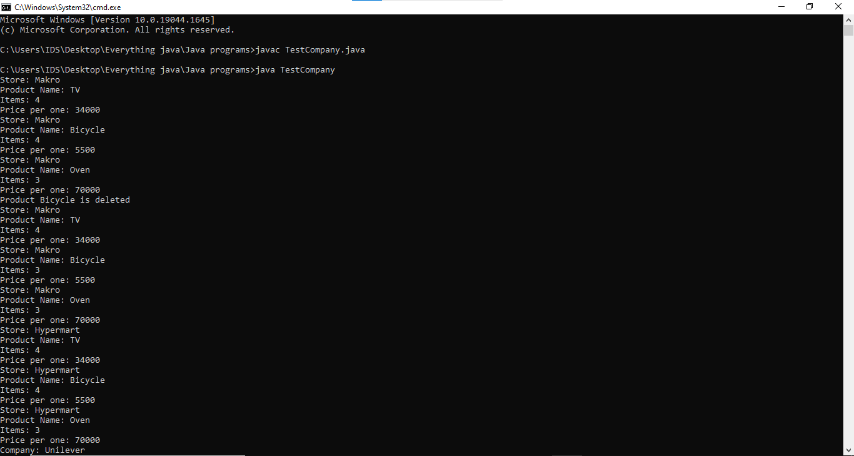

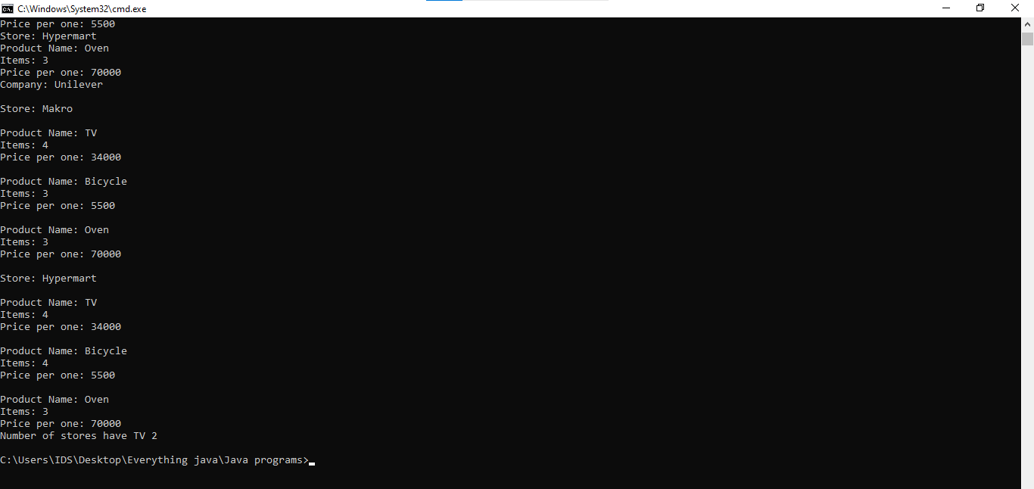

Q#3

class Person{

String firstname,lastname;

void setter(String firstname,String lastname){

this.firstname=firstname;

this.lastname=lastname;

}

String getter(){

return (firstname+lastname);

}

void DisplayDetails(){

System.out.println("First-Name: "+firstname+"\nLast Name: "+lastname);

}

}

class Student extends Person{

int id;

String course;

String teachername;

Student(String firstname,String lastname,int id,String course,String teachername)

{

super.setter(firstname,lastname);

this.id=id;

this.course=course;

this.teachername=teachername;

}

void DisplayDetails(){

System.out.println("Student \nFirst-Name: "+firstname+"\nLast Name: "+lastname+"\nID: "+id+"\nCourse: "+course+"\nteachername "+teachername);

}

}

class Teacher extends Person{

String subject;

int salary;

Teacher(String firstname,String lastname,String subject,int salary){

super.setter(firstname,lastname);

this.subject=subject;

this.salary=salary;

}

void DisplayDetails(){

System.out.println("Teacher: \nFirst-Name: "+firstname+"\nLast Name: "+lastname+"\nSubject"+subject+"\nSalary "+salary);

}

}

class Q3{

public static void main(String[] args){

Student s1=new Student("Muskan","Vaswani",5,"OOP","Faheem akhtar");

Student s2=new Student("Ameeque","Buriro",3,"OOP","Faheem akhtar");

Teacher t1=new Teacher("faheem","Akhtar","OOP",230000);

Teacher t2=new Teacher("Haseeb","Qureshi","Discrete",250000);

s1.DisplayDetails();

s2.DisplayDetails();

t1.DisplayDetails();

t2.DisplayDetails();

}

}}